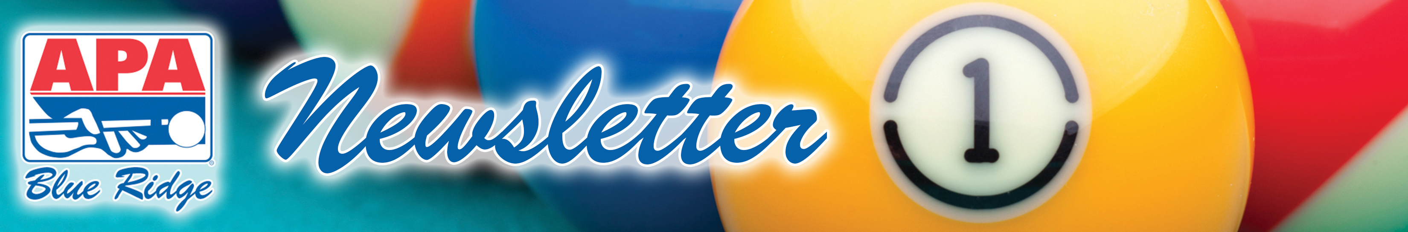

May 5, 2014: Volume XVIII – Issue 16

CUE TIP OF THE WEEK: SUMMER FUN! DON'T MISS OUT!
Blue Ridge APA has a few surprises for our players this summer, but you must be on a summer roster to take advantage of these sweet summer treats!
- Special Singles Board Sunday in July – play for free until you WIN!!!
- MVP Invitational Tournament – tiered by skill level
- EXTRA teams will qualify for next year's LTC from summer session ONLY!


THIS WEEK’S BOUNTY HUNT:
Jeff Fouts from “Team Cherokee” – there’s a bounty on your head this week. Play and win your match this Tuesday and your match is free! If his opponent (the bounty hunter) wins, then the bounty hunter plays for free! (Please note there will be no bounty during playoffs.)

SPORTSMANSHIP BALLOTS & CUP TOURNAMENT
This is the last week to cast your vote for the person in your division you believe represents good sportsmanship. Ballots are in your team packet. Please make sure every member of your team fills out a ballot – in his or her own handwriting. Winners of the sportsmanship awards will be announced 7:00 this Friday night at the Wild Card Party in downtown Asheville.

All active Blue Ridge APA members who have received a sportsmanship award throughout the league year will advance to our annual Sportsmanship Cup Tournament on Sunday, June 29th, where the champion will win a trip to play Mini-Mania tournaments in Las Vegas!

WILD CARD PARTY at Broadway''s THIS Friday
We will announce playoff standings, MVP winners, Sportsmanship Awardees, and draw for early registration (free tee-shirts for the entire team!)
- New Session Starts Monday, May 19th / Tri-Cup Sunday, June 1st
- Masters & Ladies LTC: Wednesday, June 4th and Thursday, June 5th
- 8-ball and 9-ball LTC: Friday, June 6th – Sunday, June 8th
- Jack & Jill Regionals: Sunday, June 22nd @ 1:00pm
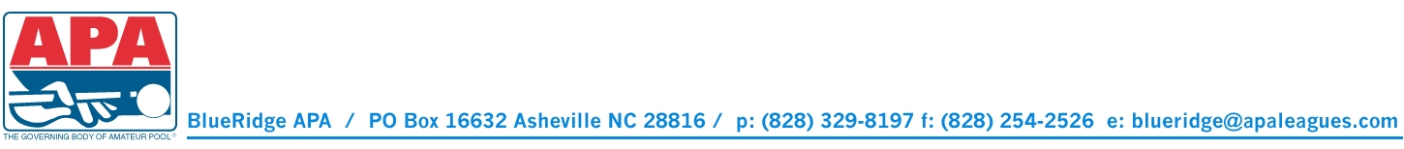
- Sportsmanship Tournament: Sunday, June 29th @ 1:00pm

